英国牛津大学人工智能专家格劳教授讲座
暨牛津剑桥暑期项目宣讲
时间：2016年3月14日14:00-16:30
地点：新校区综合业务东楼一楼多功能厅
伯纳德格劳教授简介：
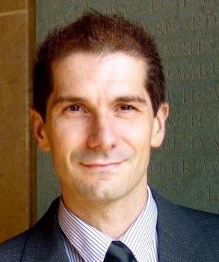
Bernardo Cuenca Grau is a Full Professor of Computer Science and a Supernumerary Fellow at Oriel College, University of Oxford. He also holds a prestigious University Research Fellowship awarded by the Royal Society.

Professor Cuenca Grau joined the Department of Computer Science from the University of Manchester. His research interests are in Artificial Intelligence and Information Systems; in particular, his research focuses on logics for Knowledge Representation, semantics-based technologies, and their applications. His research covers a wide spectrum within these areas, which includes theory and foundations, algorithm design, tool development, technology standards, and end-user applications. He has published over 100 articles in leading academic journals and conferences.

牛津剑桥暑期项目简介：
2012年，我校与牛津大学奥利尔学院签署牛津-剑桥暑期夏令营项目三方协议。迄今为止我校已有200余名学生参与到该暑期项目中。

